 | Published by UIN Fatmawati Sukarno Bengkulu  pISSN 2476-8774 | eISSN 2661-688X  Vol. 11 No. 1 Maret 2025 | Pages 100-120  https://ejournal.uinfasbengkulu.ac.id/index.php/Al-Intaj/index  This Article is licensed under a CC BY-SA 4.0 International License

The title must be written in Times New Roman, font size 14, bold, centered, and single-spaced, with a maximum length of 16 words.

Author must be written in Times New Roman, font size 11, bold, single-spaced and centered ¹*, Author²
¹Author’s affiliation must be written in Times New Roman, font size 11 and centered (ex: UIN Fatmawati Sukarno Bengkulu, Indonesia)
²Author’s affiliation
Email: author’s email adress

ABSTRACT must be written in Times New Roman, font size 10, italic, single-spaced, and should have a length of 150–250 words in total.
Purpose:
This section should clearly state the main objective of the study, including the background, context, and significance of the research. Authors should highlight why the study is important and what specific research problem it seeks to address.
Design/Methodology:
This section should describe the research approach and methodology employed, including the research design, sampling techniques, data sources, and analytical methods. The explanation must be sufficiently clear to allow readers to understand how the study was conducted.
Findings:
This section should present the key results of the research in a concise and focused manner. Authors should emphasize the most significant findings that directly answer the research questions or objectives.
Practical Implications:
This section should highlight the practical contributions of the study, particularly its relevance and applicability for practitioners, policymakers, or other stakeholders. Authors should explain how the findings can be used to address real-world issues.
Originality/Value:
This section should demonstrate the novelty and contribution of the study compared to existing literature. Authors should explain what is unique about their research and why it is valuable for advancing knowledge or practice in the field.
Keywords: Keywords should consist of 3–7 relevant terms.

Received: 28/11/2025 | Accepted: 04/03/2025 | Published: 11/03/2025

A. INTRODUCTION
The introduction must be written in Times New Roman, font size 12, with 1.15 line spacing. This section should briefly and systematically present the general background of the study, including the state of the art in the relevant field through a concise literature review. It must clearly identify the main research problem, research objectives, and provide a brief overview of the research method. The final paragraph of the introduction should explicitly state the purpose of the study.

B. LITERATURE REVIEW
The literature review must be written in Times New Roman, font size 12, with 1.15 line spacing. This section should provide a critical overview of relevant theories, concepts, and previous studies that form the foundation of the research. Authors are expected to highlight research gaps, theoretical contributions, and the novelty of the study in relation to existing literature.

C. METHOD
This section applies only to research articles. The method must be written in Times New Roman, font size 12, with 1.15 line spacing. This section should clearly describe the research design, data sources, data collection techniques, and data analysis procedures, providing sufficient detail to ensure transparency and replicability.

D. RESULT AND DISCUSSION
This section applies only to research articles. The result and discussion must be written in Times New Roman, font size 12, with 1.15 line spacing. This section should not be explicitly titled as “Results and Discussion,” but organized into appropriate subtitles that reflect the themes of the findings. The results must be supported with sufficient and relevant data, while the discussion should explain the relationship between the findings and the research objectives, provide scientific interpretations, and compare the outcomes with previous studies to highlight consistencies or differences. Finally, this section must demonstrate the contribution of the study to the advancement of knowledge in the field.
Tables and figures must be presented in a clear and consistent manner, with captions placed above each table or figure. Figures should be of high quality and sufficient resolution to ensure readability. When applicable, the source of the table or figure must be provided below it. The source must be written in Times New Roman, font size 12, and Italic.

Table 1. Variable Descriptions
Variable Name | Variable Description
Household Income Characteristics
Income | Household monthly income (in million Rupiah)
Vulnerable Household Characteristics
Lack of money for food needs | Household lacks money to afford food (1 = Yes, 0 = No)
Difficulty obtaining food | Household experiences difficulty obtaining food (1 = Yes, 0 = No)
Household Characteristics
Receiving food assistance | Household receives government food aid (1 = Yes, 0 = No)
Number of family members | Total number of household members (people)
Consuming healthy food | Household consumes balanced, nutritious meals (1 = Yes, 0 = No)
Head-of-Household Characteristics
Male | Gender of head of household is male (1 = Yes, 0 = No)
Age | Age of head of household (years)
Education level | Years of education completed by head of household
Working in the formal sector | Head of household works in the formal sector (1 = Yes, 0 = No)
Source: processed by the authors, 2025.

Figure 1. Agricultural Waqf Bank Financing Model
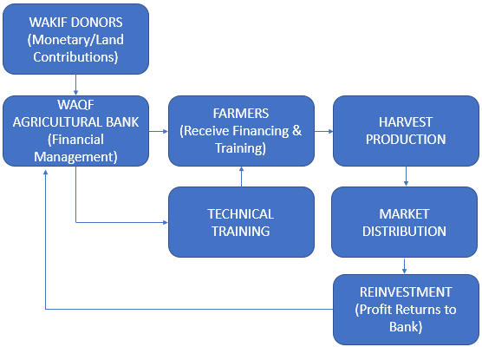
Source: Modified by the authors, 2025.

E. CONCLUSION
The conclusion must be written in Times New Roman, font size 12, with 1.15 line spacing. This section should directly address the research objectives and summarize the key findings. It must go beyond merely repeating the results, discussion, or abstract. Authors should highlight the implications of the study, acknowledge its limitations, provide practical recommendations, and suggest directions for future research.

F. BIBLIOGRAPHY
The bibliography must be written in Times New Roman, font size 12, with single-spaced. The citation system must follow a bodynote style, with all sources listed in the references corresponding to those cited in the footnotes. Authors are required to use reference management software such as EndNote, Mendeley, or Zotero. At least 80% of the sources must consist of journal articles, conference proceedings, or other scientific works published within the last five years. References must be formatted in accordance with the American Psychological Association (APA) 7th edition style.

